Auckland Museum Trip
On Tuesday 9th of April, Room 7 went to Auckland War Memorial Museum. We went with the whole of Waipipi School. We went there to look at the Kiwiana objects from the past.
We travelled to the museum by Harker’s buses. I was travelling in Bus 3 and I was sitting next to Hayden. We were counting how many white cars went past. We counted 303. Zac’s drink bottle spilt onto the floor so when the bus went up a hill, the water went down to the end of the bus!
When we got to the museum, we had morning tea. Then we went into the museum. I was in Jalen’s group. We went into the gallery.
In the gallery, there were Maori carvings and a canoe or Waka. There were greenstone clubs and taihas.
Next we went to the Wild Child exhibit. We sat on the benches and desk while Mr Miles talked about a child's school life.
After that, we went to the Volcano exhibit. There were 3 rocks to lift. I could lift all of the rocks. Then we went into the Volcano Room. Zac didn’t want to do it. But he did.
We watched One News on the TV in the Volcano Room. They were talking about the volcanoes when suddenly the room shook and the TV went black. Then a huge eruption came through the water and the room shook. Then it went all black. The TV said ‘The Aftermath’. Then a man came and told us about volcanoes. We then left the room.
We went to the Coastal Exhibits. We looked at the crabs that we were standing on. We also looked at the other fish and amphibians. They were really cool.
Then we went to Weird & Wonderful. There were all kinds of insects and reptiles. We also went on the tablets and looked at the pictures and videos. Next we left for the WWI and WWII exhibits.
We looked at the street. There were lots of shops. We went through the trenches. There was a gattling gun and a large plane. There were lots of sandbags. We looked at all of the rifles and pistols. They were awesome.
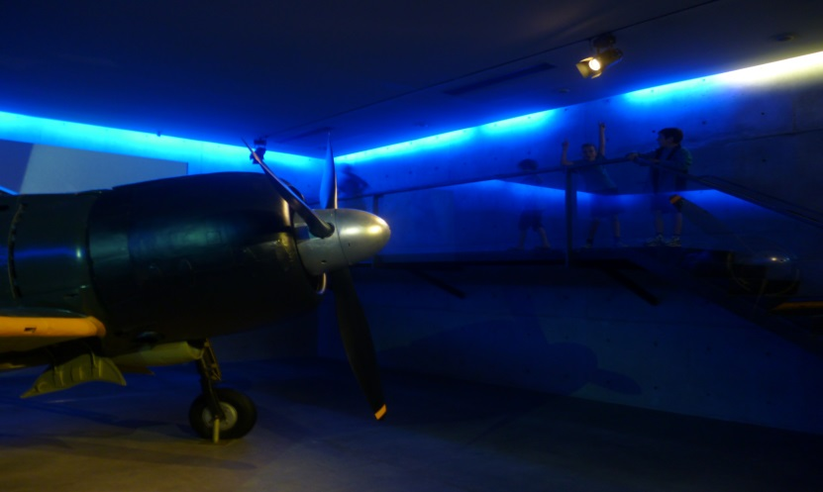
After that we went out of the museum we had lunch. We then went back to the buses and got on. We drove back to school. Zac and I played Sweet & Sour. We got lots of sweets. Zac’s drink bottle fell on the floor again. We got to school and after 15 minutes the bell rang and we went home.
By Jack Newton

