**JELLY TIP/ TIP TOP**

By Jalen Harper[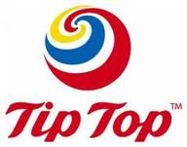](http://www.google.co.nz/imgres?q=tip+top&hl=en&safe=active&biw=1249&bih=681&tbm=isch&tbnid=brfGaXfGj2pRcM:&imgrefurl=http://topnews.net.nz/content/21059-20-reduction-size-some-ice-cream-tubs-undertaken-tip-top&docid=TeJgX_5UhaZXTM&imgurl=http://topnews.net.nz/data/imagecache/bigthumb/images/Tip-Top.jpg&w=240&h=189&ei=aIdHUdjULsL2lAWAsIAY&zoom=1&sa=X&ved=0CHsQhBwwDw&ved=1t:3588,r:15,s:0,i:123&iact=rc&dur=673&page=1&tbnh=151&tbnw=192&start=0&ndsp=18&tx=113&ty=43)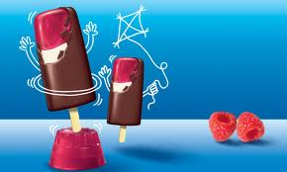

There are 35 million litres of ice cream, 106 million ice blocks and 14 million trumpets a year.

JELLY TIP TUBS

Creamy vanilla flavoured ice cream with gooey raspberry flavoured jelly and chocolate flakes tumbled through it and made by the kiwi brand Tip Top.

New Zealanders 4.2 million people population, consume around two million jelly tips a year.

A delicious combination of creamy vanilla ice cream, made from fresh milk and cream tipped with raspberry jelly coated in choc.

A birthday treat on a stick that kids can enjoy wherever they are at home or out an about and is also made in the 1950s.