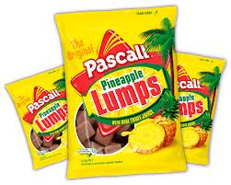
Pineapple Lumps are a flavoured chocolate covered confectionery with a soft, chewy pineapple-flavoured middle from New Zealand. They are often identified as Kiwiana. The semi-brittle shell of chocolate conceals a chewy, soft pineapple flavoured centre.

The first Pineapple Lumps were made by the Regina confectionery factory (now called Rainbow factory ^{[1]}) in Oamaru around ^{[2]} 1952-54. Charles Diver, the confectionery chef and floor production manager at Regina, who would later create other classic kiwi sweets, was given the task of using up waste product from other lollies of the time. One sweet in particular, an early version of the chocolate fish with a banana flavouredmarshmallow middle, had the most left overs

The first Pineapple Lumps were made by the Regina confectionery factory (now called Rainbow factory ^{[1]}) in Oamaru around ^{[2]} 1952-54. Charles Diver, the confectionery chef and floor production manager at Regina, who would later create other classic kiwi sweets, was given the task of using up waste product from other lollies of the time. One sweet in particular, an early version of the chocolate fish with a banana flavouredmarshmallow middle, had the most left overs

