Tip Top Ice cream! 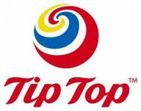
Tip Top is a company who makes ice cream. Tip Top also makes bread. There is a big factory in Auckland. Lot’s of people like Tip Top.
The story of Tip Top is not known for sure but it is believed that Hayman and Malaghan were having a discussion in a train over night when one of the passengers said that his food was “Tip Top” and they immediately decided that they would like to hear people say that about their ice cream. Then an ice cream business was born!
Tip Top produces around 50,000,000 litres of ice cream a year and gets the milk from Fontera. Tip Top is exported to lots of places around the world.
Tip Top produces lots of different flavours of ice cream and is very good at selling!
By Laura Nicholson
